**University of British Columbia**

Faculty of Applied Science, School of Engineering

**Heat Treatment Project**

**Table of Contents**

1.0 Introduction 2

2.0 Objectives 2

3.0 Design Considerations 3

3.1 Methods 3

3.2 Results 7

4.0 Discussion 7

5.0 Conclusion 8

Appendix A 9

**1.0 Introduction**

The objective of this project was to design a gear that would be used in an excavation drill gearbox. Due to the intensive conditions of the work the gear would be constantly enduring it had to be designed with specific characteristics so that it could perform its task. Among these were different hardness readings at certain stages of the gear such as throughout, at the center, and at 0.2mm below the surface. The measurements were read in the HRC scale or the Hardness Rockwell C scale. While we were provided with five alloys to consider initially, we quickly eliminated the 8610 alloy since we were unable to find any information online about it and it did not fit some of our initial considerations. Other constraints we had to work with were our operational capacities such as our maximum temperature we could work with was 950 degrees Celsius and 170 psi for our maximum pressure.

Apart from the design aspect of this we also had to optimize the cost of the operation. Assuming that our gear would start at room temperature and average room pressure of 20 degrees Celsius and 14.6 psi respectively; we had to take into consideration that the general operation would cost $1 per minute, a degree increase would result in a $0.18 charge per hour, and the pressure would cost an additional $1.75 psi/hour. Knowing this we were able to derive an equation for the cost and create over a thousand iterations of this process in Microsoft Excel. The iterations covered from start to a maximum of four hours, and at each time broken up into fractions of 0.1 the cost was calculated along with its corresponding pressure and time.

**2.0 Objectives**

The objective of this project is to design a gear that would be used in an excavation drill box. For the design of the gear, the following material requirements had to be taken into consideration:

1. Minimum hardness throughout the component: 40 HRC
2. Maximum hardness at center: 50 HRC
3. Range of diameter: 15-22 mm
4. Maximum heat treatment time: 4 hours
5. Minimum hardness 0.2 mm below the surface: 62 HRC
6. Quenching medium: Agitated water or Oil
7. Available alloys: 8610, 8620, 8630, 8640, and 8660
8. Relationship between pressure and carbon content given as follow: P: in Pascal
9. Maximum allowable pressure: 170 psi
10. Maximum achievable temperature: 9500C
11. Cost considerations: Every operating minute costs $1, increase in temperature by a degree costs 18¢ per hour, the system pressure costs $1.75 per hour

**3.0 Design Considerations**

**3.1 Methods**

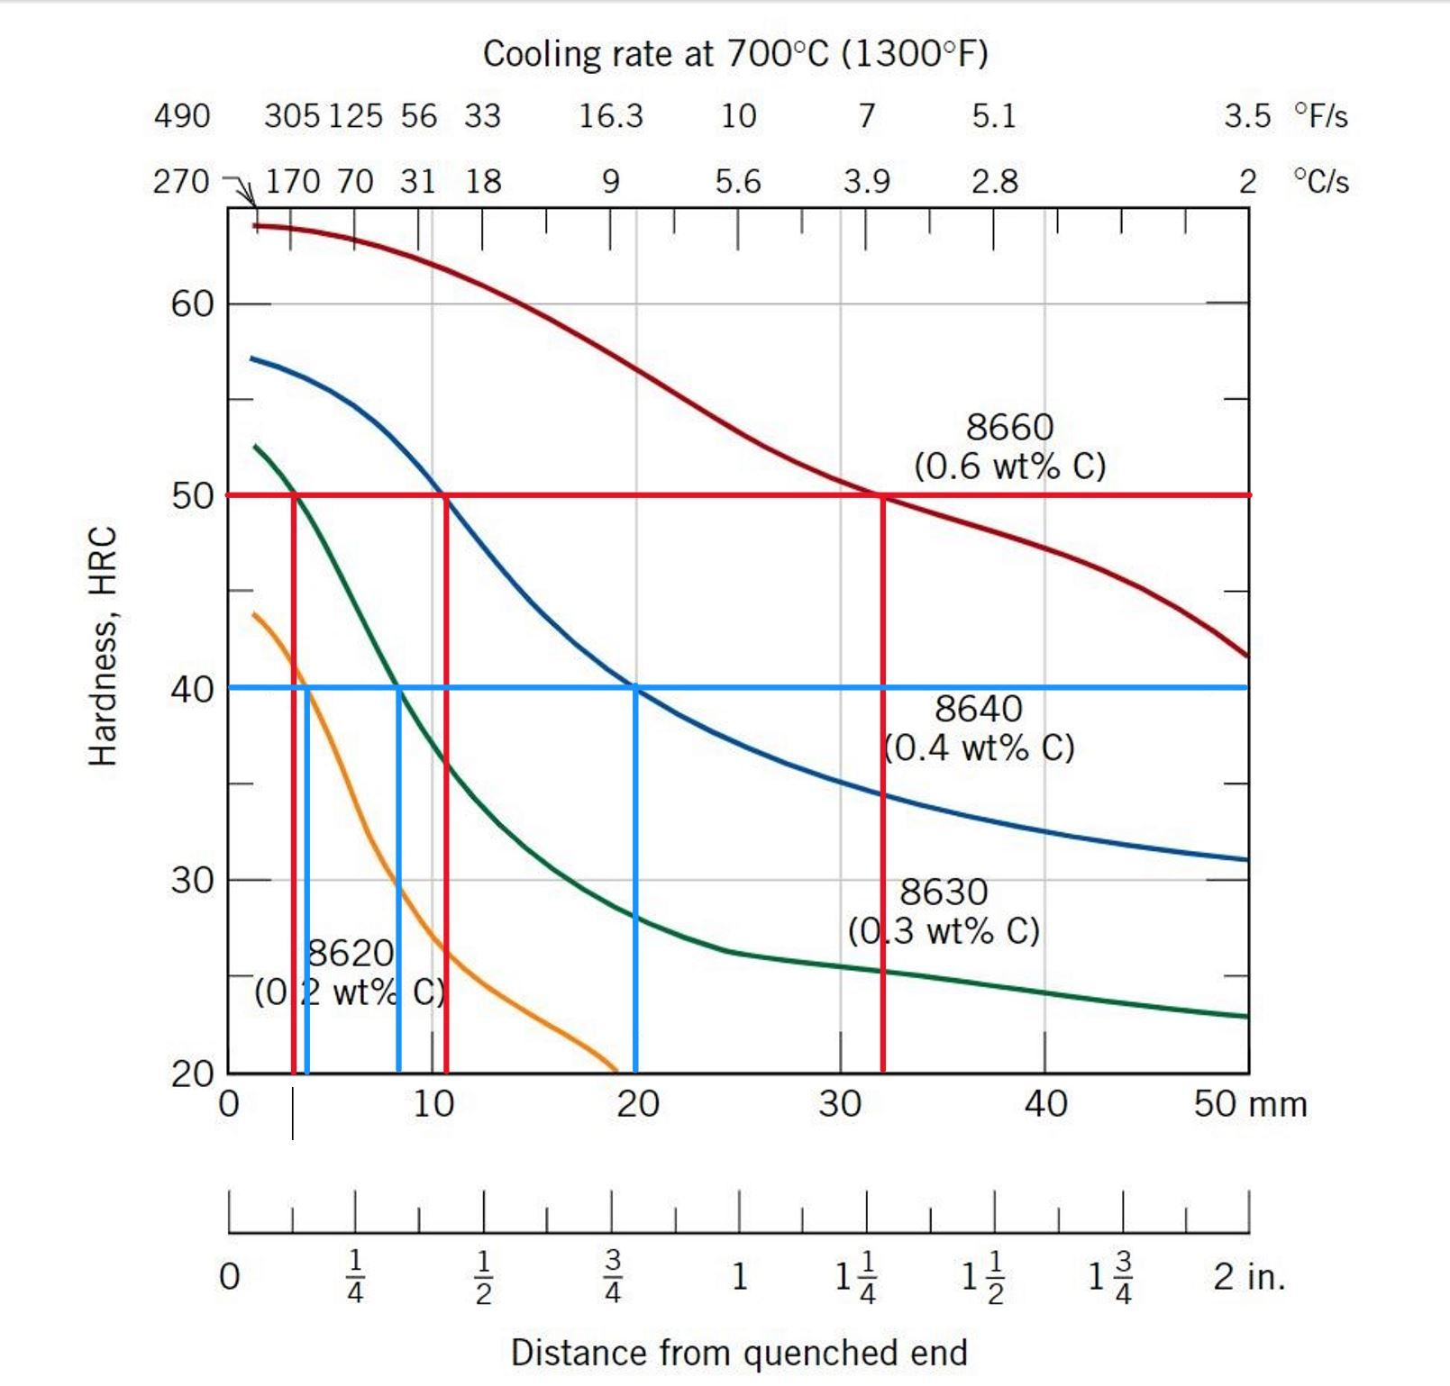

*Figure 1: Material Hardness and Jominy Distances For 8600 Series Alloys*

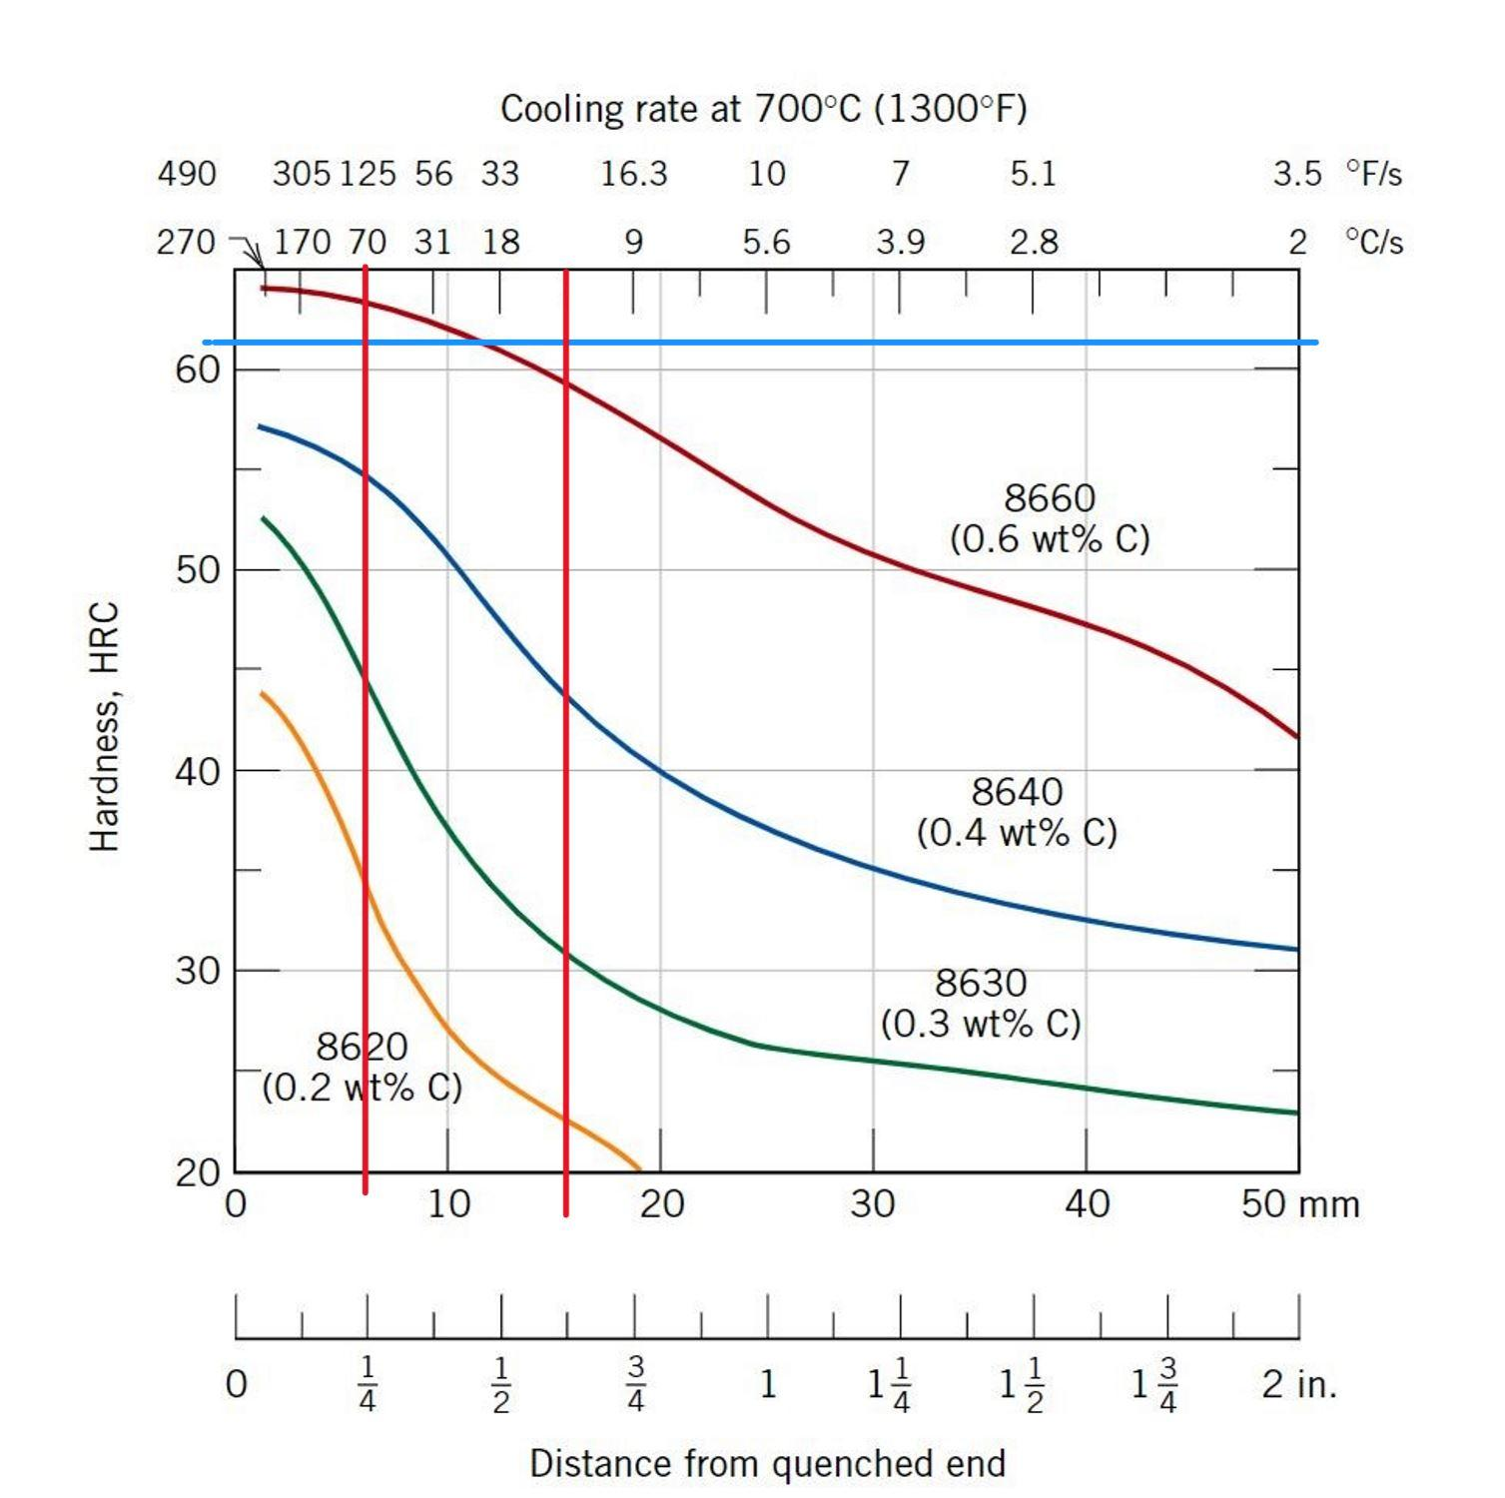

*Figure 2. 62 HRC with the Jominy Distances for Agitated Water and Oil*

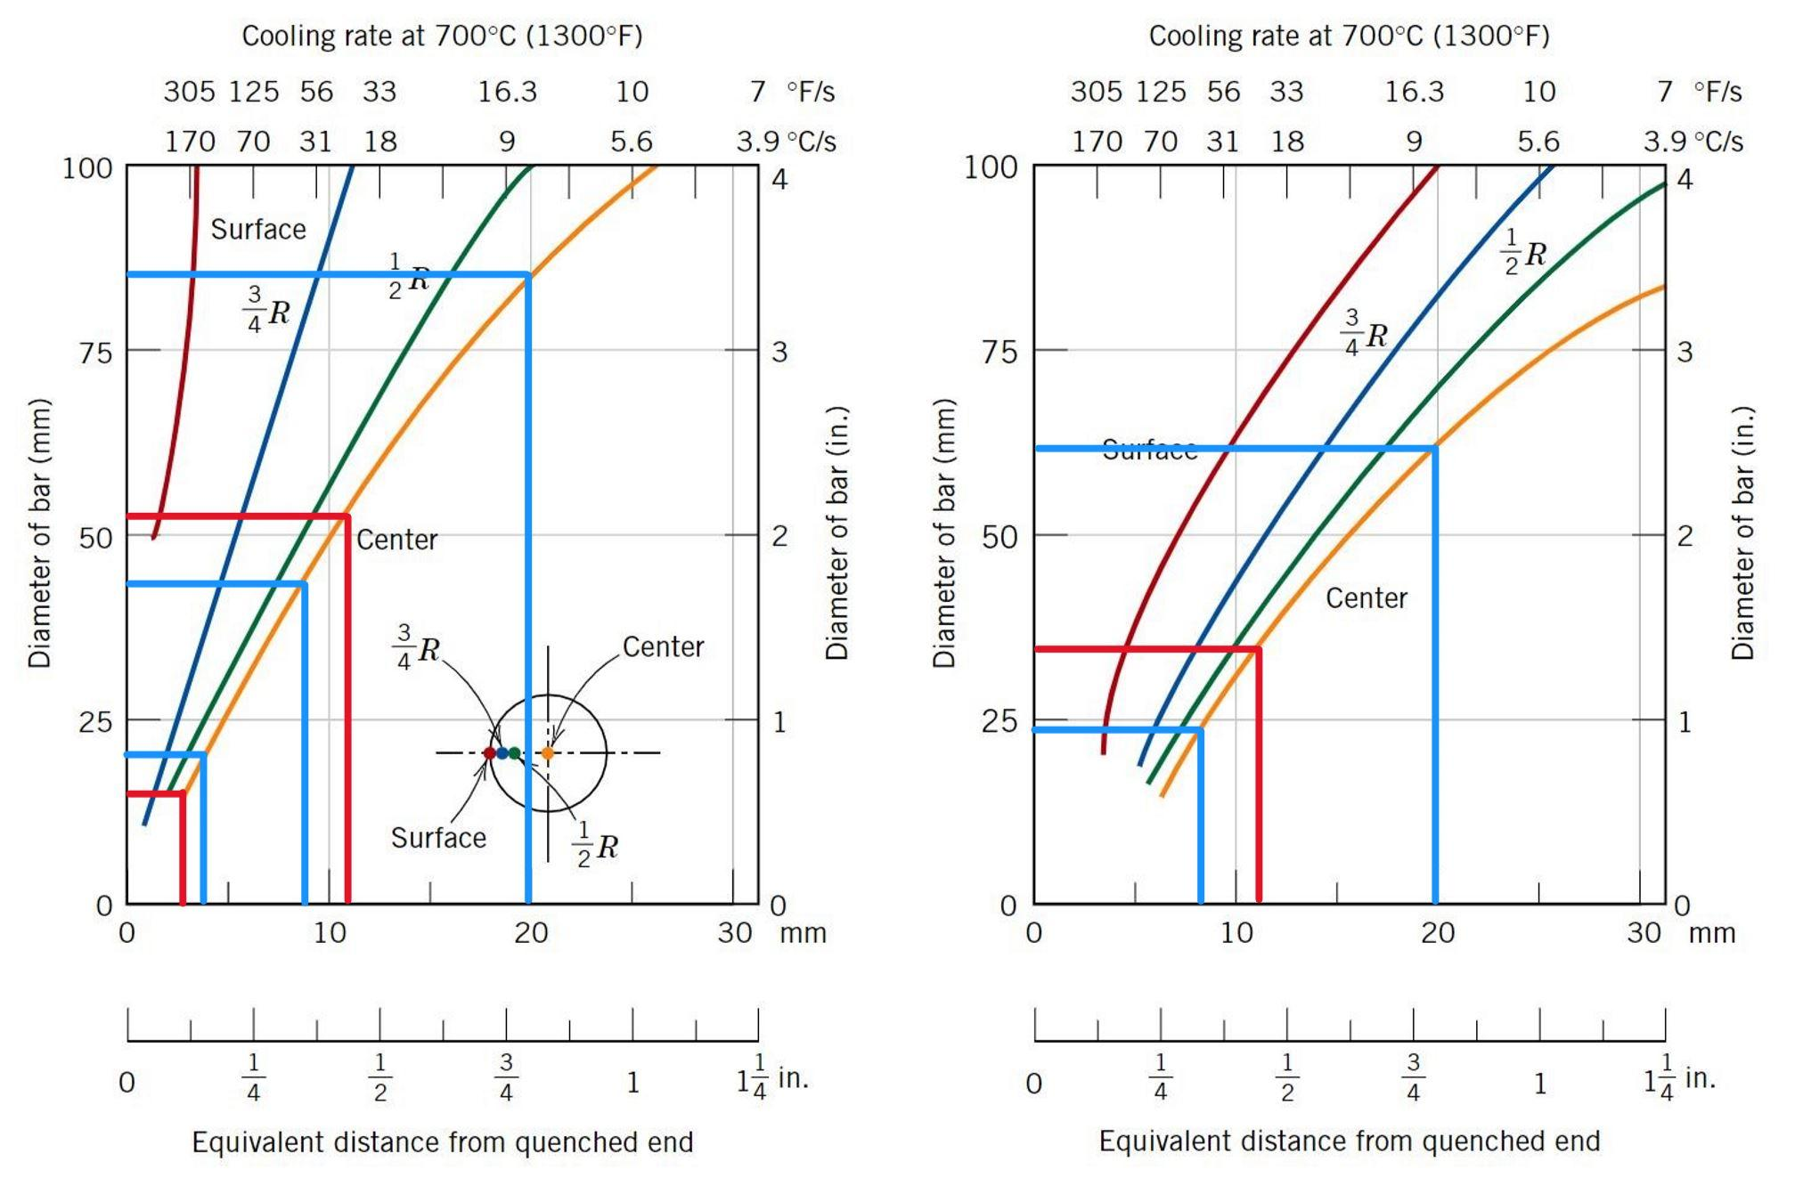

*Figure 3: Jominy Distance and Material Diameter for Oil & Water Quenching*

|  |  |  |  |  |
| --- | --- | --- | --- | --- |
|  | 40 HRC Center | | 50 HRC Center | |
| Alloys | Max Jominy Distance(mm) | Max Diameter(mm) | Min Jominy Distance(mm) | Min Diameter |
| 8610 | N/A | N/A | N/A | N/A |
| 8620 | 4 | 20 | N/A | N/A |
| 8630 | 8 | 41 | 3.5 | 15 |
| 8640 | 20 | 83 | 11 | 54(too large) |
| 8660 | >32 | >100(too large) | 33 | >100(too large) |

*Table 1: Center Hardness for Quenched in water*

|  |  |  |  |  |
| --- | --- | --- | --- | --- |
|  | 40 HRC Center | | 50 HRC Center | |
| Alloys | Max Jominy Distance(mm) | Max Diameter(mm) | Min Jominy Distance(mm) | Min Diameter |
| 8610 | N/A | N/A | N/A | N/A |
| 8620 | 4 | N/A | N/A | N/A |
| 8630 | 8 | 23 | 3.5 | N/A |
| 8640 | 20 | 60 | 11 | 33(too large) |
| 8660 | >33 | >100(too large) | 33 | 85(too large) |

*Table 2: Center Hardness for Quenched in oil*

1. From Figure 1, we can already eliminate using the 8610 alloy as the figure suggests that said alloy is too weak to fulfill the material requirements. Moving down the list of alloys, the 8620 alloy could obtain 40HRC on the surface quenched in water, however Figures 1 and 2 suggest that the material is too weak to obtain any of the other requirements, regardless of whether water or oil is used to quench the material. The 8630 alloy looks promising in all aspects. The 8630 alloy can obtain the material requirements with a diameter between 15-41mm if quenched in water, and a maximum diameter of 23mm when quenched in oil with a negligible minimum diameter for our scenario. These possible dimensions allow for us to achieve our desired dimensions of 15-22mm. The 8640 and 8660 alloys both display good material properties, however they must be ruled out as too large of a diameter would be needed to achieve our desired hardness.

As a result of this analysis, we will be looking at the 8630 alloy as our material for this project.

1. Another requirement of the material is a hardness of 62HRC at 0.2mm below the surface. From Figure 1, we can see that 8660 will be our desired finished material that is capable of having 62HRC using a quenching medium of agitated water. From this figure we noticed that using Oil as a quenching medium would not be possible since none of the alloys would hold up in the hardness considerations. Thus, we must calculate the time and temperature through the use of diffusion analysis. Other conditions that must be met in this process is a depth of 0.2mm below the surface, less than 170psi, time of less than four hours, and a temperature of less than 950oC. To solve for these variables, the following formulas were used.The D0 chosen was 2.3x10^-3 since our gear would be in the austenite region as shown in Figure 4, the Iron-Carbon phase diagram. The full formulas may be seen in Appendix A.

D = D0exp(-Q/RT)

(Cx-C0)/(Cs-C0) = 1 - erf(x/2)

Cs = (Cx-C0)/(1-erf(x/2)) + C0

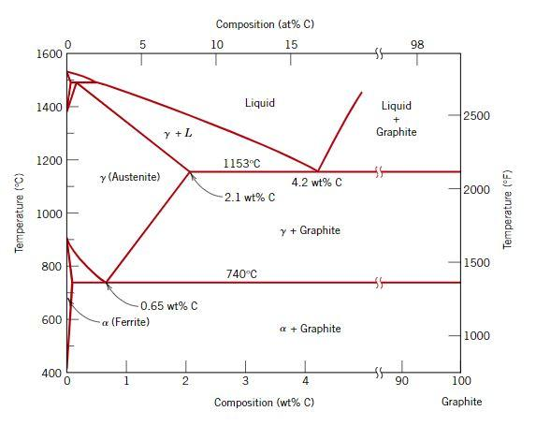

*Figure 4: Iron-Carbon Phase Diagram*

1. The last component of consideration was to pick the right combination of components that would result in the lowest cost of operation. From the givens we were able to derive the cost equation below and perform over a thousand iterations of combinations of time, temperature, and pressure that resulted in different cost calculations from which a sample from the Excel file can be seen below in Figure 5. What is shown in that sample was repeated at every 0.1 interval up to 4.0 hours. To avoid going through each row and checking to see if the limits were not exceeded and which had the lowest cost, we programmed excel to only highlight pressures under 170psi and the bottom 10% of costs. This made it easier to find that at 0.7 hours with temperature at 950 degrees, and 169 psi we achieved our lowest cost.

Cost = $1*(t/60s) + $0.18*((Tx-(20+273.15))*(t/3600s)) + $1.75*((Px-14.6psi)*(t/3600s))

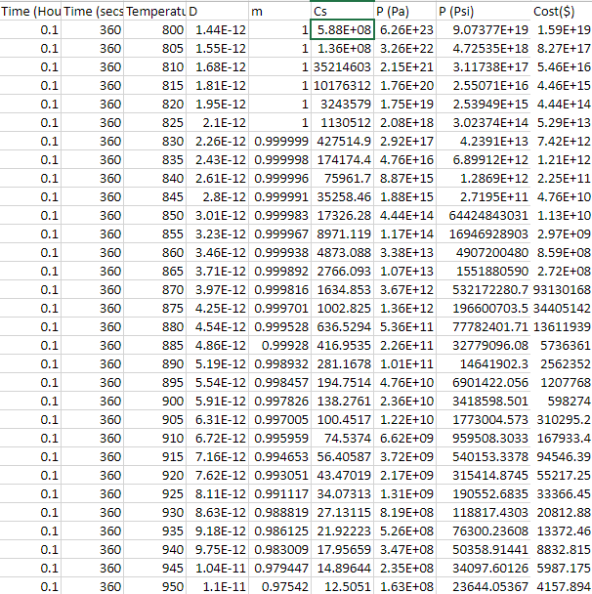

*Figure 5. Excel File Sample*

**3.2 Results**

To summarize, we knew that we wanted the gear to be made of 8660 alloy steel but if we started off with it, the minimum diameter of our gear would be too large. Therefore, we knew we had to start off with a lower carbon concentration, 8630, and heat it to a high temperature and carburized with a carbon enriched gas at a high pressure in order to meet the design requirements. The temperature, carbon content of gas, and pressure were all determined by the cost equation and the optimized setup was 950 degrees Celsius, 1.058wt% C gas, and 169.4 psi for 0.7 hours or 42 minutes to achieve the lowest cost of $348.81 per gear.

**4.0 Discussion**

To find the most suitable alloy for the gears hardness requirements, the graphs in Figures 1, 2 and 3 were used. These graphs contained the jominy distance vs hardness, and the jominy distance vs diameter for quenching in either agitated water or oil. Ultimately, 8630 was chosen as the most suitable alloy as both of the design properties were achievable regardless of if the gear was quenched in water or oil. The 8610 and 8620 alloys both did not meet the hardness requirement of 50HRC at the middle, while the 8640 and 8660 alloys both would have needed too large of a diameter to reach the required hardness.

While the 8630 alloy was the most ideal material for the 40HRC and 50HRC requirements, the material does not have the capability to reach a hardness of 62HRC at 0.2mm below the surface without some alteration. To achieve this hardness, we will carburize the material in carbon enriched gas, which will increase the carbon concentration of the gear from 0.3wt%C to 0.6wt%C, which is what will be needed to reach a hardness of 62HRC. Additionally, to reach this hardness we will need to quench the material in water, as quenching in oil will not allow the material to reach a hardness of 62HRC due to the Jominy distance of oil not reaching 62HRC.

Another factor of this design process is to find the most economical way to produce the gear, meaning we had to find the most ideal time and temperature to produce the gear with. This was achieved by first calculating the diffusivity of the alloy, which allowed for calculation of the surface concentration and therefore the time, pressure, and temperature. Calculations for this process may be found in Appendix A. Due to the alloy needing to be carburized by a gas, the carbon concentration of the gas also had to be calculated, which was found to be 1.058wt%C. Calculations for these processes may be found in Appendix A.

The ideal conditions were obtained by creating a cost equation which was then used in an excel spreadsheet. The spreadsheet calculated each variable depending on the time and temperature. From the calculations, the ideal temperature and time was 9500C, for a duration of 0.7 hours or 42 minutes. Additionally, the calculations provided an ideal pressure of 169.4psi, which is just below the design threshold of 170psi. Ultimately, these conditions would help to produce a gear at a cost of $348.81 per gear, which was the lowest cost among all of the time and temperature variations.

**5.0 Conclusion**

For this project, we were tasked with creating a gear from a set of 8600 series alloys which had to meet certain design requirements. After analyzing several material property charts, the 8630 alloy was determined as the most suitable alloy for the gear based on the materials hardness and diameter properties. From a series of calculations centered around a cost equation, the most economical conditions to produce the gear were able to be found. The ideal process would be to heat treat the 8630 alloy for 0.7 hours at 9500C while at 169.4psi, then carburized in a 1.058wt%C enriched gas, which after it will be quenched in water. The final product would have a minimum 40HRC hardness throughout, 50HRC hardness at the center, and a 62HRC hardness 0.2mm below the surface. The gear would come at a cost of $348.81 per gear, which is the cheapest option given the initial conditions. This project has helped us gain valuable knowledge about the production of a product, which will surely be a useful asset for our futures working in the engineering industry.

**Appendix A: Sample Calculations**

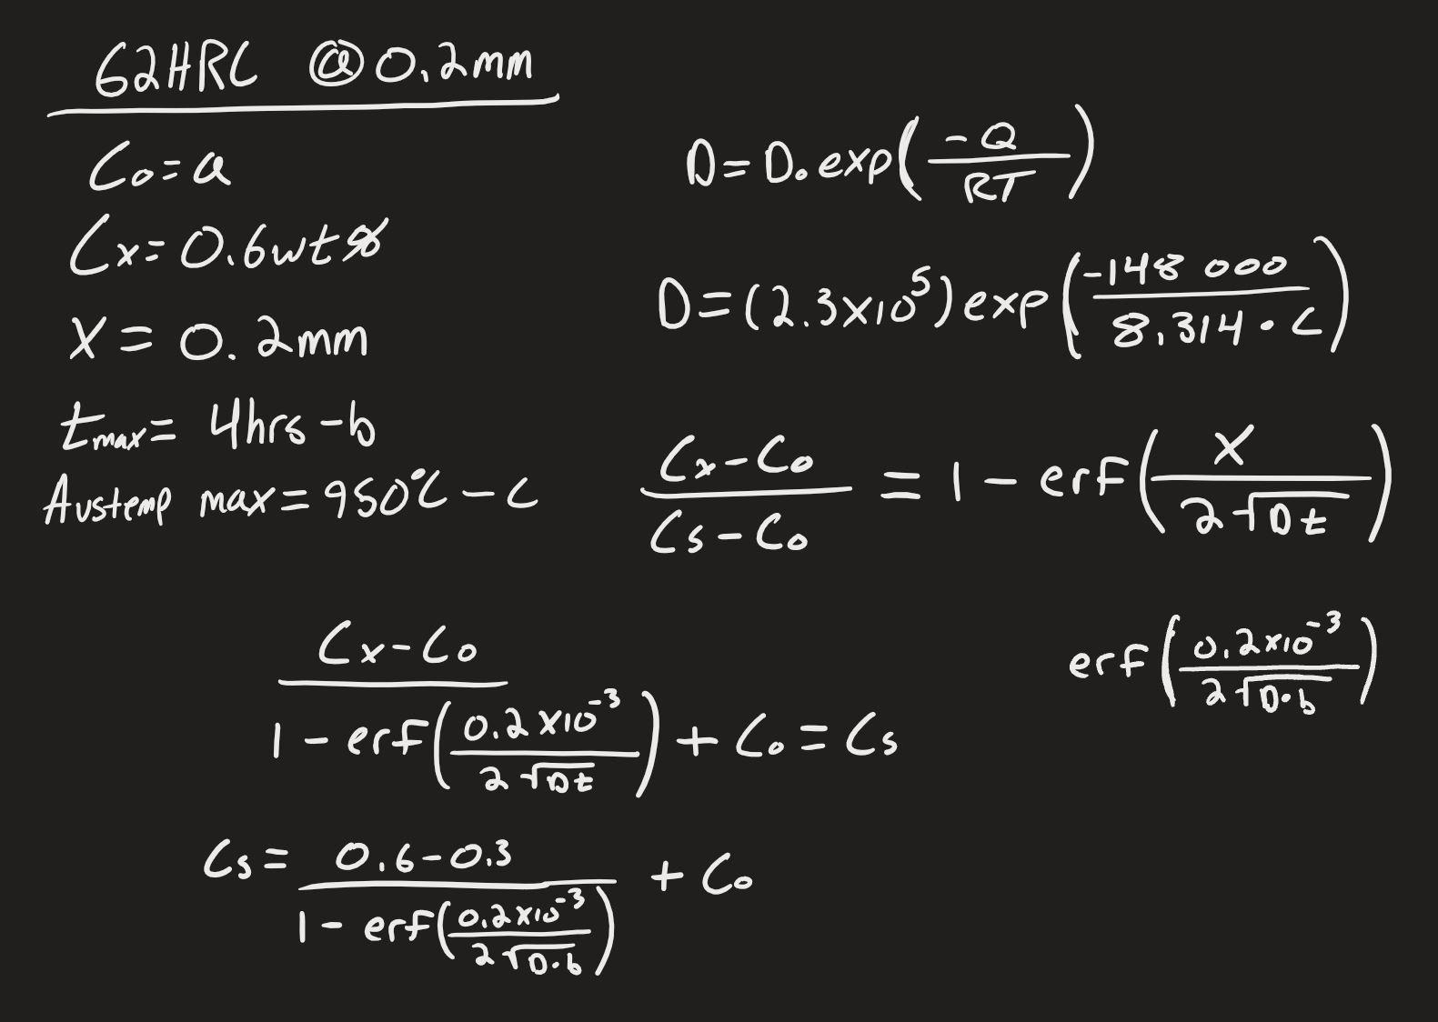

*Figure 6: Calculating for 62HRC at 0.2mm Below the Surface*

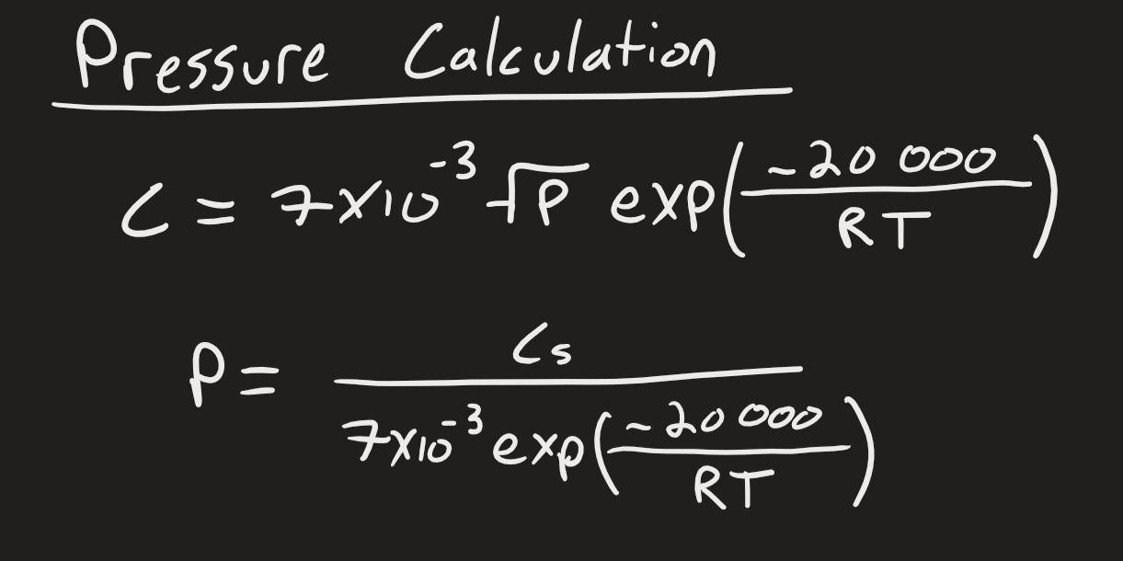

*Figure 7: Pressure Calculation*

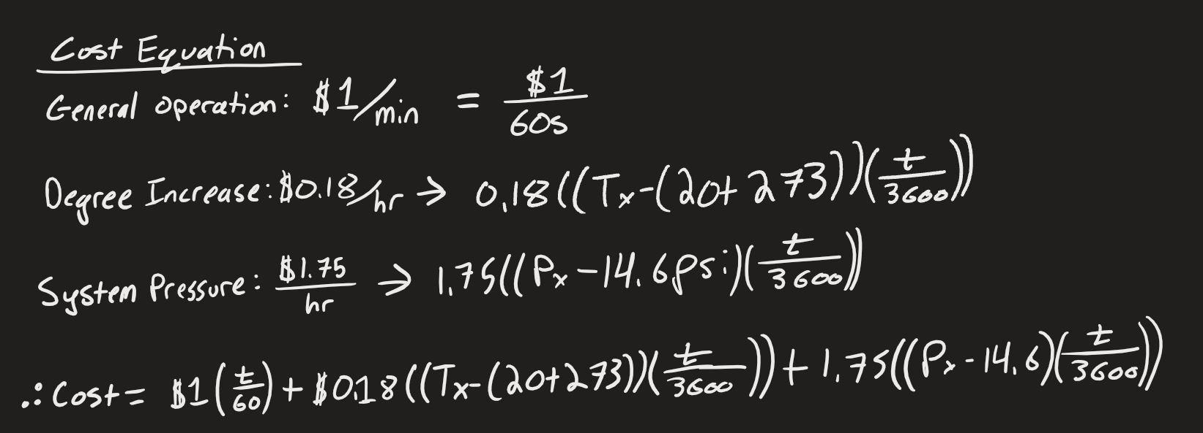

*Figure 8: Cost Equation Sample Calculation*